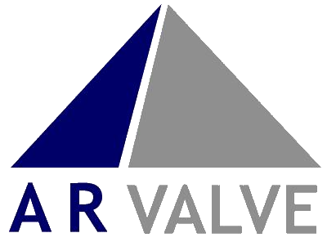

In stock!

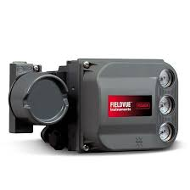

DVC6200

The highly sought-after DVC6200, a versatile device renowned for its advanced features and seamless performance is now in stock. The Fisher FIELDVUE DVC6200 instrument allows for your operation to run closer to setpoint, improving product quality with more accurate control. Using FIELDVUE Performance Diagnostics, valve operation is monitored online to evaluate performance and reliability.

DVC2000

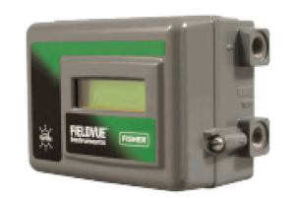

The popular DVC2000 model, a cutting-edge device known for its innovative features and user-friendly interface is now in stock. The DVC2000 has gathered lots of high rated reviews for its performance and simplicity, the Fisher FIELDVUE DVC2000 instrument allows for your operation to run closer to setpoint, improving product quality with more accurate control.

AR Valve Resources Limited, Unit 91 Thomas Way, Lakesview International Business Park,

Hersden, Canterbury, Kent, UK, CT3 4NH

Telephone: +44 (0) 1227 719133 Facsimile: +44 (0) 1227 714919

Email: sales@ar-resources.com Web: [www.ar-resources.com](http://www.ar-resources.com)

**Registered in England No. 4639300. VAT Reg. No. 776 1752 01**



**DVC6200:**

|  |  |  |
| --- | --- | --- |
| MODEL | PRODUCT NUMBER | NOTES |
|  |  |  |
| DVC6200 | DVC-3793-4337794 | DVC6200 - ALUM, HC, ATEX, DOUBLE ACTING, 0-160 COC |
| DVC6200 | DVC-3793-4348479 | DVC6200 - ALUM, PD, ATEX, SINGLE ACTING, 0-160 COC |
| DVC6200 | DVC-3793-4336909 | DVC6200 - ATEX/AD/G160B SINGLE ACTING COC |
| DVC6200 | DVC-3793-4371264 | DVC6200 - ATEX/SIS/G160B SINGLE ACTING COC |
| DVC6200 | DVC-3793-4337703 | DVC6200 - HC, ATEX, SINGLE ACTING, POSITION TRANSMITTER, 0-160 COC |
| DVC6200 | DVC-3793-6456985 | DVC6200 - ALUM. FM/HC/G160B SINGLE ACTING COC |
| DVC6200 | DVC-3793-5561497 | DVC6200 - SS/ATEX/HC/G160B SINGLE ACTING COC |
| DVC6200 | DVC-3793-4337391 | DVC6200 - ALUM, HC, ATEX, SINGLE ACTING, 0-160 COC |
| DVC6200 | DVC-3793-4337391 | DVC6200 - ALUM, HC, ATEX, SINGLE ACTING, 0-160 COC |
| DVC6200 | DVC-3793-8446449 | DVC6200 - ATEX/SIS/G160B, M20, POSITION TRANSMITTER, SINGLE ACTING COC |
| DVC6200-PD | DVC-3793-4383559 | DVC6200 - ALUM, PD, IECEX, DOUBLE ACTING, 0-160/0-1.1MPA |
| DVC6200F-SC-FD | DVC-3793-4229498 | DVC6200F - ALUM, FF,SC,FD, ATEX, SINGLE ACTING, 0-160 |

AR Valve Resources Limited, Unit 91 Thomas Way, Lakesview International Business Park,

Hersden, Canterbury, Kent, UK, CT3 4NH

Telephone: +44 (0) 1227 719133 Facsimile: +44 (0) 1227 714919

Email: sales@ar-resources.com Web: [www.ar-resources.com](http://www.ar-resources.com)

**Registered in England No. 4639300. VAT Reg. No. 776 1752 01**

**DVC2000:** 

|  |  |  |
| --- | --- | --- |
| **MODEL** | **PRODUCT NUMBER** | **NOTES** |
|  |  |  |
| DVC2000 | DVC-3787-4360071 | DVC2000, HC, ATEX, POSITION TRANSMITTER  AND LIMIT SWITCH, 1.3-3.4 RELAY COC |
| DVC2000 | DVC-3787-4385953 | DVC2000, HC, ATEX, POSITION TRANSMITTER  AND LIMIT SWITCH, 3.4-7.0 RELAY COC |
| DVC2000 | DVC-3787-4385919 | DVC2000, HC, IECEX, POSITION TRANSMITTER  AND LIMIT SWITCH, 1.3-3.4 RELAY COC |
| DVC2000 | DVC-3787-4385977 | DVC2000, HC, ATEX, POSITION TRANSMITTER  AND LIMIT SWITCH, 1.3-3.4 HOUSING A (GX) |
| DVC2000 | DVC-3787-4353109 | DVC2000, HC, ATEX, POSITION TRANSMITTER  AND LIMIT SWITCH, 3.4-7.0 HOUSING A (GX) |
| DVC2000 | DVC-3787-4360071 | DVC2000, HC, ATEX, SINGLE ACTING 1.3 to 3.4 barg (20 to 49 psig), TRANSMITTER, LIMIT SWITCH |

AR Valve Resources Limited, Unit 91 Thomas Way, Lakesview International Business Park,

Hersden, Canterbury, Kent, UK, CT3 4NH

Telephone: +44 (0) 1227 719133 Facsimile: +44 (0) 1227 714919

Email: sales@ar-resources.com Web: [www.ar-resources.com](http://www.ar-resources.com)

**Registered in England No. 4639300. VAT Reg. No. 776 1752 01**